Bandit War Game
- Course: Foundation of Information Technology
- Course code:IT1113
- Semester 1-ICA 03

Registration No:2022ICT23
Name: S.A.M.S.Samaraweera

Bandit War Game is,
A game focus on basic linux command line skills which teaches how to navigate directories, last files, read file contents and search techniques like ls, cat, cd and more.
Lets get in to the levels step by step.

Bandit War Game :Level 0

- First, we have to open a terminal. Here,I use command prompt application.
- In the beginning of the game we use SSH to remotely connect to a machine.This protocol SSH aims for a secure communication between the machines.
- Then I logged into the sever using bandit.labs.overthewire.org and username used was bandit0 and password is bandit0.

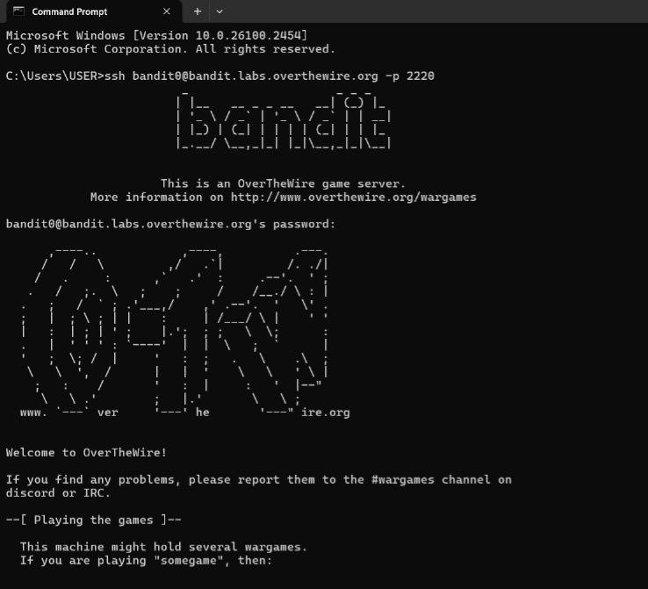
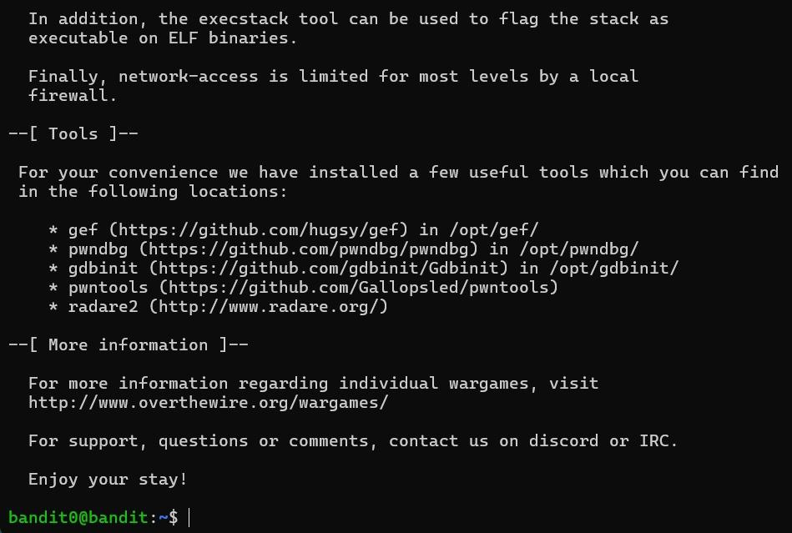

Bandit War Game :Level 0 – Level 1
The password for the next level is stored in a file called readme located in the home directory. Use this password to log into bandit1 using SSH. Whenever you find a password for a level, use SSH (on port 2220) to log into that level and continue the game.
- commands used : ls, cd, cat
Now we get the password we need to log into bandit1 using SSH.
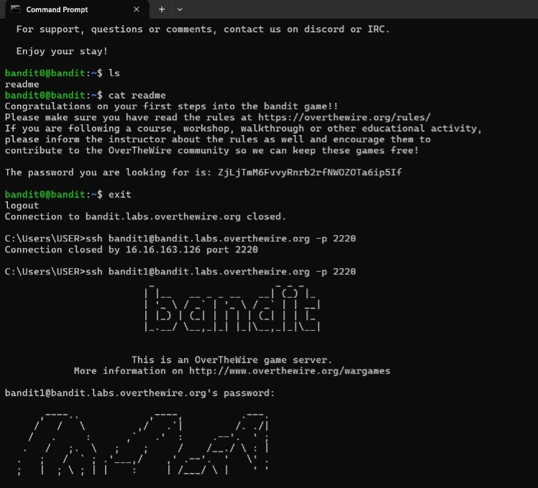

Bandit War Game :Level 1 – Level 2
The password for the next level is stored in a file called — located in the home directory.

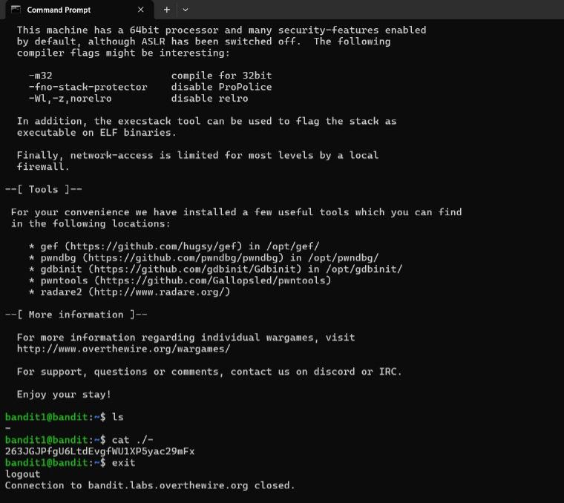

Bandit War Game :Level 2 – Level 3
The password for the next level is stored in a file called spaces in this filename located in the home directory. so we need to add a backward slash (\) after each word.
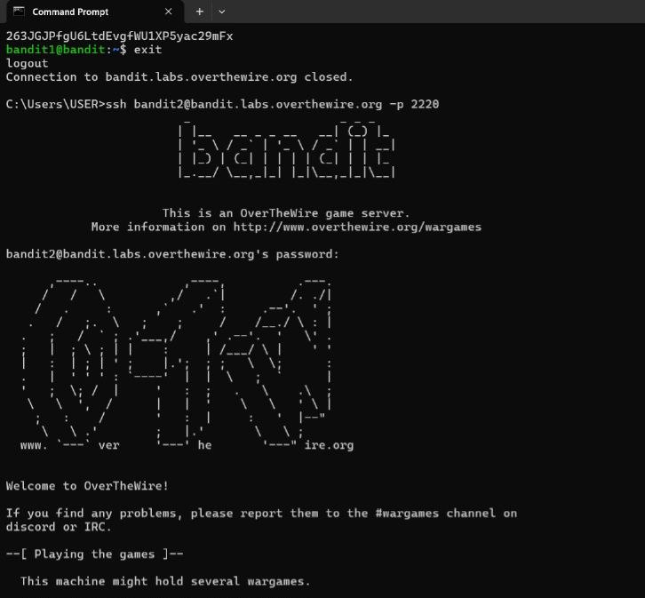
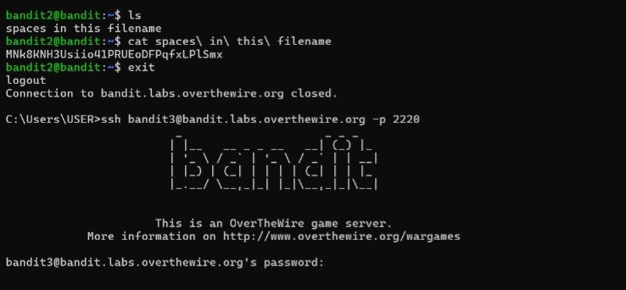

Bandit War Game :Level 3 – Level 4
The password for the next level is stored in a hidden file in the Inhere directory.
- command used : ls, cd, cat
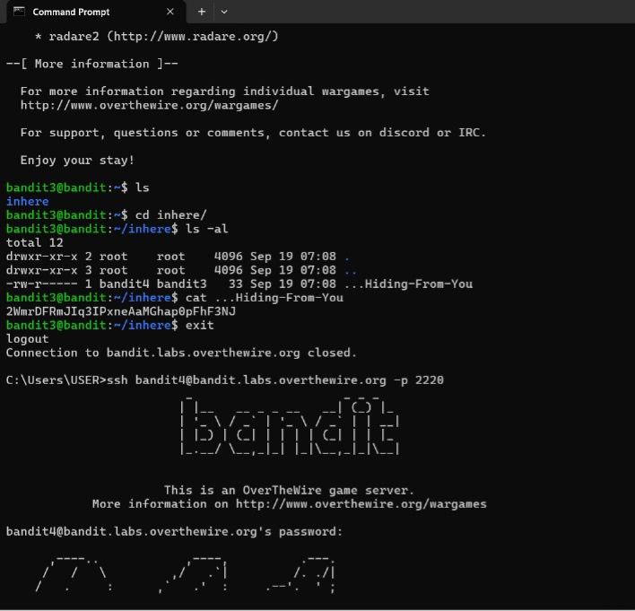

Bandit War Game :Level 4 – Level 5
The password for the next level is stored in the only human-readable file in the inhere directory. Tip: if your terminal is messed up, try the “reset” command.

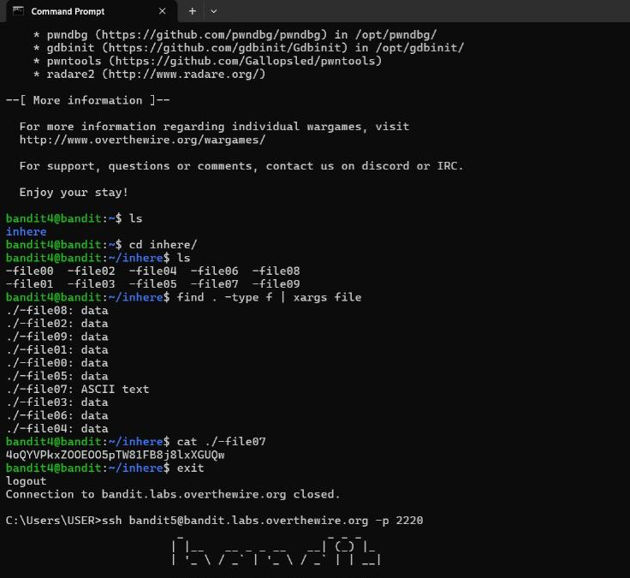

Bandit War Game :Level 5 – Level 6
The password for the next level is stored in a file somewhere under the inhere directory and has all of the following properties:
- human-readable | 1033 bytes in size | not executable
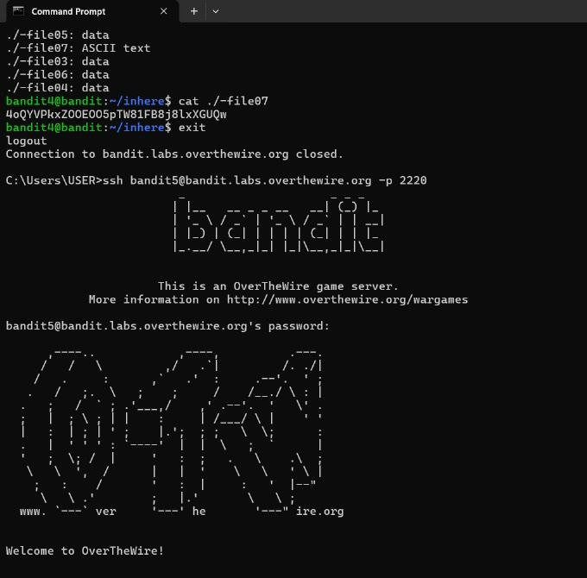
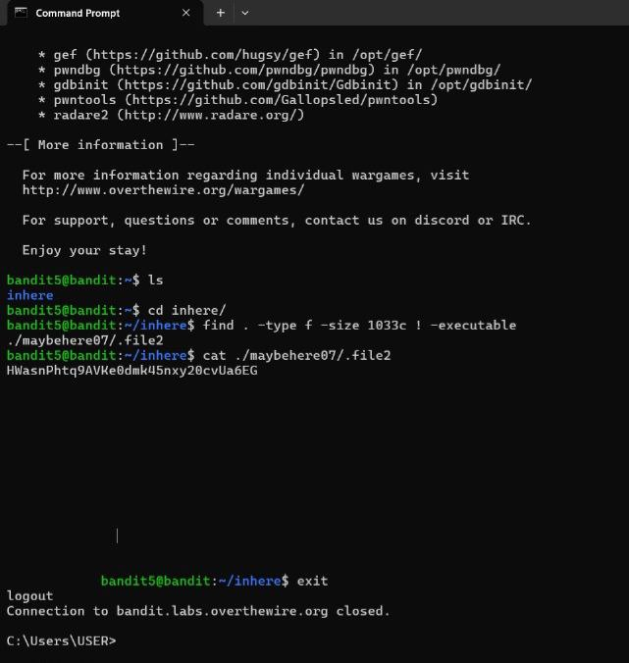

thank you

